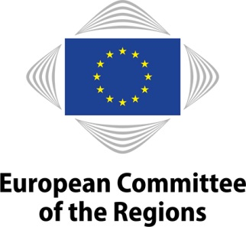 | 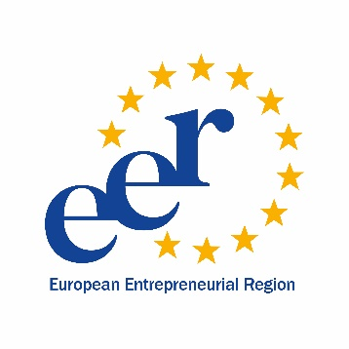

European Entrepreneurial Region (EER) Award 2021
Call for applications

The Secretary-General of the European Committee of the Regions (CoR) invites EU territories to submit their applications for the 2021 edition of the European Entrepreneurial Region (EER) Award.

In accordance with decision 2518/2019 of the CoR Bureau, the EER label is open to all EU territories below the level of the Member State that are endowed with competences at a political level and able to implement an overall entrepreneurial vision, regardless of their size, wealth or specific competences. It does not matter whether a territory has legislative competences or not. Each applicant's budget, specific structural or territorial challenges and economic starting point are taken into account by the EER jury.

Regions are defined in the broadest sense, including communities, autonomous communities, departments, Länder, provinces, counties, metropolitan areas, cities, as well as cross-border territories with legal personality such as EGTCs and Euroregions. In order to be eligible, the applicant must have the necessary political competence to implement a comprehensive policy strategy aimed at mainstreaming some or all SBA principles.

The theme of the EER 2021 call is Entrepreneurship for a green & sustainable future. The EER jury may award thematic labels in addition to normal EER labels. Applicants are requested to indicate their interest in the thematic EER label in the application form.

Applications will be evaluated according to the criteria set out in Bureau decision 2518/2019.

The award of a thematic EER label shall in addition be subject to the assessment of the quality and credibility of the applications' link with the theme of the annual EER edition.

1) Political vision and commitment

- The application demonstrates a future-oriented political vision for implementing the Small Business Act for Europe in the territory, focusing, where appropriate, on the current SBA priorities and on the principles of related policy initiatives, such as the Entrepreneurship 2020 Action Plan, Green Action Plan for SMEs, Start-up and Scale-up Initiative and Strengthening Innovation in Europe's regions.
- The application demonstrates the commitment of the territory to implement its political vision taking account of the rapidly changing economic landscape and key megatrends, e.g. increased globalisation, digitalisation, the new industrial revolution, the changing nature of work, demographic changes and the transition to a circular and low carbon economy.
- The application is based on a realistic assessment of the territory's strengths and weaknesses (SWOT analysis) and its direct competences with respect to the ten SBA principles. The context and unique starting point of each applicant are taken into account by the members of the jury.
- The political vision demonstrates a clear added value of the EER award for the territory, including for its own policy-making.
- The territorial EER objectives are embedded in a regional development and/or smart specialisation strategy and are guided by the overarching framework of the Sustainable Development Goals;
- The competent political authorities demonstrate a strong and credible commitment to implementing the EER strategy in the territory.

2) Multilevel governance, partnership and cooperation

- The EER strategy is prepared and implemented following a multilevel governance approach involving both the lower levels (municipalities etc.) and, where possible, the national level.
- A broad range of relevant actors is involved in the design and implementation of the EER strategy, including economic and social partners, learning and research institutions, and civil society.
- There is a demonstrated capacity and will to exchange good practices with other regions and to develop specific cooperation initiatives with other EER regions.

3) Delivery

- The strategy includes concrete actions that contribute to the implementation of entrepreneurship policies that fall within the territory's competences through the EER scheme and does not merely synthesise existing policies.
- The implementation of EER actions follows the principles of good governance and includes effective mechanisms for monitoring and follow-up.
- The use of relevant indicators, which will follow the progress of the implementation.
- The application includes measures to ensure optimal use of European Structural and Investment Funds and other public funding.
- The application demonstrates how the EER actions will be sustainable beyond the EER year.
- The projected actions take the social, environmental, innovative and durable growth enhancing dimensions of SME policy into account whenever possible.

4) Communication

- The application includes an ambitious and convincing communication plan with specific actions at the highest level that are directed at all key target groups (including SMEs and other relevant actors).
- The EER label will be used to publicise the territory's policy both within the territory and at EU level.
- The planned communication actions will enhance the visibility of the CoR and of the EU.

Applicants are asked to submit an application consisting of the following items:
- an application form, including a fact sheet on the applicant territory, an outline of its political vision, a description of foreseen governance mechanism to ensure efficient implementation of the EER actions, as well as an action plan and a communication plan;
- a declaration of political commitment demonstrating that the territory's EER strategy is endorsed by its political leadership (e.g. the regional assembly, the regional government or other authorised political bodies).

The application form can be downloaded from the EER web page: https://cor.europa.eu/en/engage/Pages/european-entrepreneurial-region.aspx

The deadline to submit applications is set at 31 March 2020. Applications not received within this deadline are deemed not eligible.

