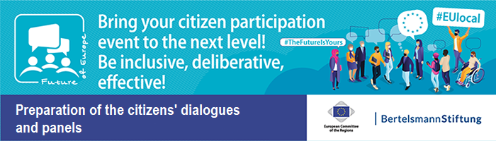
Examples for Warm-Up Questions

Collection of Materials on „Programme design and conceptualisation“ – Document 17

Questions to familiarize with the participants

10 Finger Exercise
I would like to know how you are doing. We will practise the 10 Finger Exercise. 10 fingers means: I am doing excellent, 1 finger means: I am not doing well at all. Please show as many fingers as you feel.

Camera on /Camera off or stand up Exercise
I'll say something and if that suits you, please turn your camera on / stand up.
• I slept well and enough
• I have had enough for lunch
• I have already done some sport today.

Estimate the distance from your home to Brussels. How far do you live from Brussels?
- 0 - 200 km
- 200 - 500 km
- 500 - 1000 km
- More than 1000 km

Questions with connection to the event

Have you ever participated in a digital citizens' dialogue?
- Yes
- No

How much are you interested in politics in general?
- Very much
- A bit
- Not at all

Think about the future of the EU. What are you?
- Very optimistic
- Rather optimistic
- Rather pessimistic
- Very pessimistic

How satisfied are you with the EU? I am ...
- Very satisfied
- Rather satisfied
- Rather unsatisfied
- Very unsatisfied

How well are you informed about EU politics?
- I feel very well informed
- I feel rather well informed
- I feel rather uninformed
- I feel very uninformed

