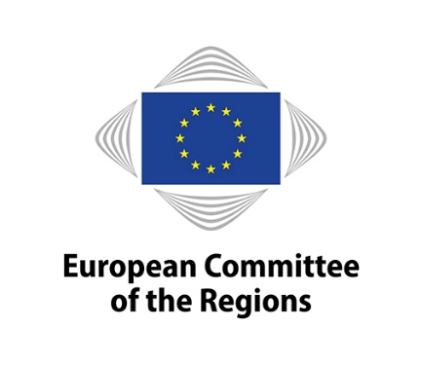
COTER-VII/044
26th commission meeting on 12 December 2024
EN

WORKING DOCUMENT

Commission for Territorial Cohesion Policy and EU Budget

Metropolitan regions and functional urban areas as socio-economic drivers of sustainable investment in the 2020-2027 cohesion policy framework

_____________

Rapporteur: Carmine PACENTE (IT/ renew E.)
Member of Milan City Council
_____________

This document will be discussed at the meeting of the Commission for Territorial Cohesion Policy and EU Budget to be held from 11:00 to 17:30 on 12 December.

Introduction and background

Policy context and analysis of the policy area

EU urban policy has been aligned with EU cohesion policy to promote harmonious development to overcome regional disparities and strengthen economic, social and territorial cohesion in line with Article 174 TFEU. The debate on urban policy takes place at intergovernmental level between EU ministers responsible for urban matters and has led to the consolidation of an EU ‘urban acquis’, later translated into an EU policy framework for sustainable urban development in Europe and the Urban Agenda for the EU:

The Pact of Amsterdam is the founding document for the Urban Agenda for the EU, and was launched in 2016.

The New Leipzig Charter adopted by EU ministers responsible for urban matters in November 2020 sets strategic principles of good urban governance and provides a framework guiding post-2020 urban policy coordination in Europe and defines green, just and productive cities, social innovation and green transition, and integrated and urban development strategies at neighbourhood or functional area level.

The Territorial Agenda 2030 adopted by EU ministers responsible for spatial planning, territorial development and/or territorial cohesion in December 2020 is a strategic framework document that underlines the importance of and provides orientation for strategic spatial planning and calls for strengthening the territorial dimension of sector policies at all governance levels.

Why is the topic relevant for local and regional authorities in the EU?

Migration from rural to urban areas in Europe is rapidly increasing, with the level of urbanisation expected to increase to approximately 84% in 2050, combined with a tendency of continuing urban sprawl and merging of urban zones into metropolitan areas. Metropolitan regions are considered to be engines of economic growth and centres of research and innovation, cultural and social progress. However, the density of settlement and the larger interdependencies introduce various challenges. It is local authorities who are at the forefront of grasping these opportunities and addressing the challenges by ensuring integrated urban development strategies that provide well-designed and implemented policies to achieve sustainable urban growth. The need for integrated and coordinated actions among territories is also reflected in increasing attention to functional area approaches to promote urban development. This focus also led to the introduction of a general definition of functional urban areas in the EU in 2019.

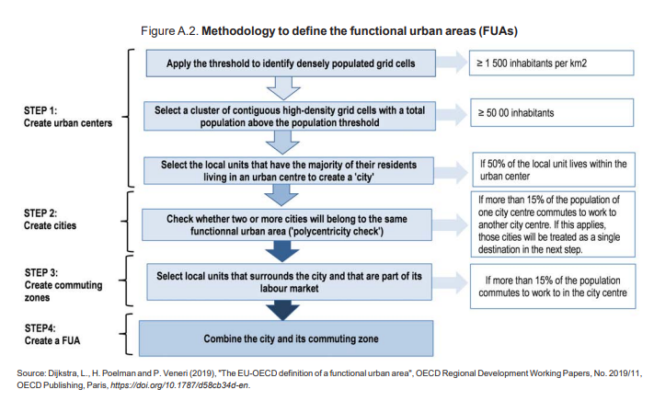

The concept of functional urban areas is becoming increasingly relevant to various EU policies and therefore they benefit from diverse EU funds due to their mixed urban, suburban and rural characteristics. With the introduction of the European Green Deal, the EU has launched different initiatives towards cities in support of green, digital and inclusive transformations, but cohesion policy remains the main EU source of support for sustainable urban development with a financial envelope of EUR 24.4 billion from the European Regional and Development Fund (ERDF) in the 2021-2027 period.

Since the 2014-2020 programming period, cohesion policy has supported territorial and urban development strategies and empowered urban authorities and territorial bodies in the management of EU funds with strong local partnerships. Integrated Territorial Investment (ITI) and Community-Led Local Development (CLLD) territorial tools have been deployed to implement these strategies. In the 2021-2027 programming period EU Member States allocated 12% of the total ERDF for sustainable urban development.

Funding to sustainable urban development, by specific objective 2021-2027

Source: Cohesion Open Data Platform

Place-based and functional area approaches are well recognised in cohesion policy as drivers of regional and rural attractiveness and reinforcement of urban-rural linkages, with targeted support below national level – to regions and cities. However, there is still a need to enhance multi-level governance and the mechanisms of collaboration at all levels (local-regional-national) to ensure effective cooperation in strategic (spatial and urban) planning and to better address financial needs. Currently, access to funding and the use of multi-funding sources (including beyond public funding) are identified as key operational needs of local authorities in supporting sustainable urban projects.

Key questions for the debate

- What experience do you have in using 2021-2027 cohesion policy and other EU funds for urban projects? What were the main advantages and disadvantages you encountered? Have you managed to integrate different funding sources for your urban investments?
- What territorial delivery tools have been used in your region/locality in the cohesion policy context – Integrated Territorial Investments (ITI), Community-Led Local Development (CLLD), other territorial instruments? What is your experience?
- What can cohesion policy do better to address urban development needs? What do you want to see in the ambitious policy agenda for cities that the next Commissioner for Cohesion and Reforms should put forward?
- How do you perceive the role of the Urban Agenda for the EU and EU Territorial Agenda in setting the architecture of the EU funds post-2027? Do you see them merged in the expected Commission policy agenda for cities?
- Would you see a continued role for other policy and funding instruments beyond cohesion policy under shared management (e.g. the European Urban Initiative, an RRF-type approach, Cities mission)? If so, how would you propose to ensure a strategic approach, avoiding duplication and overlaps on the one hand and gaps on the other?
- What role do you see for the private sector? How can this be taken forward post-2027?
- What (further) support do you consider is needed as regards technical and administrative capacity of municipalities and beneficiaries?
- How can we stimulate the construction of a new urban agenda that rewards the aggregation of functional and urban areas, compared to individual municipalities, to address the challenges of the future?
- How can we leverage the administrative, technical and financial capacity demonstrated by urban areas and metropolitan areas in the implementation of cohesion policies and the Recovery and Resilience Facility (RRF)?
- How can we ensure new forms of protagonism for urban areas and metropolitan areas?
- What changes and innovations should be introduced into the regulations of cohesion policy after 2027?
- What is the best way to strengthen the role of urban areas and metropolitan areas in the programming of policies and investments, going beyond territorial strategies?
- What mechanisms and tools could be used to improve the implementation of investments, defining a governance that serves urban areas and metropolitan areas?
_____________

Developments and Forecasts on Continuing Urbanisation, Knowledge for policy.
Eurostat (2018), Methodological manual on territorial typologies. Metropolitan regions are urban agglomerations (NUTS level 3 regions or groups of NUTS level 3 regions) where at least 50% of the population lives inside a functional urban area (FUA) that is composed of at least 250 000 inhabitants. Functional urban areas consist of a city and its commuting zone. The EU and OECD have adopted a common methodology to identify a functional urban area.
GHSL-OECD functional urban areas, Publications Office of the EU.

