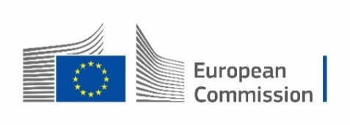
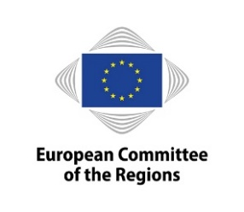


1st Digital Participatory Forum
GenAI for Public Administration Info Day

Date: 22 May 2025
Time: 11.00 – 16.30
Location: hybrid meeting at the European Committee of the Regions, rue Belliard 99/101, Brussels – room JDE 51 (5th floor) and online

Agenda:

Moderators: Ivana Zeppa and Elaine Zaunseder, DG Connect

11.00 – 11.15 Welcome

Lucilla Sioli, Director of the AI office of the European Commission
Alberto Cirio, Chair of the ECON commission and President of the Piedmont region

11.15 – 12:15 Info Session on the Digital Europe Programme Call on GenAI for Public Administration

Presentation of the call for proposals by Cecile Huet, European Commission
Explanation of the B2match tool by Sarah Pehar, B2 Match

Q&A

12:15 – 13.15 Pitches by public administrations and start-ups

13.15 – 14.10 Networking lunch @ Atrium (6th floor)

Moderators: Marek Bobis and Anke Schuster, European Committee of the Regions

14.10 – 14.30 Coffee Break

Interpretation EN, DE, FR, IT, PL

14.30 – 15.30 Apply AI: Policy context and AI use cases for public administrations

Presentation of a methodology to identify impactful AI use cases for public administrations and stakeholder feedback through Slido.
Melhem Daoud, DG Connect, and Luca Tangi, JRC

Experiences and perspectives of the digital building permit in Germany
Andreas Fiedler, brain-SCC

Q&A

15.30 – 16.15 Connecting cities and regions as an essential part of digital transformation in the EU

Eddy Hartog, member of the Senate, The Netherlands
Ivan Goychev, Eurocities, Deputy Mayor Digitalization and Innovation, Sofia, Bulgaria
Pehr Granfalk, CoR Member, rapporteur on EU Cyber Solidarity Act and Digital Resilience
Fausto Matos, Member of the Cabinet of Executive Vice-President Virkkunen, European Commission

Q&A

16.15 – 16.30 Closing Remarks

